Week 02 Tutorial Activities

Task 1 - View Your Addresses.

Get-NetAdapter

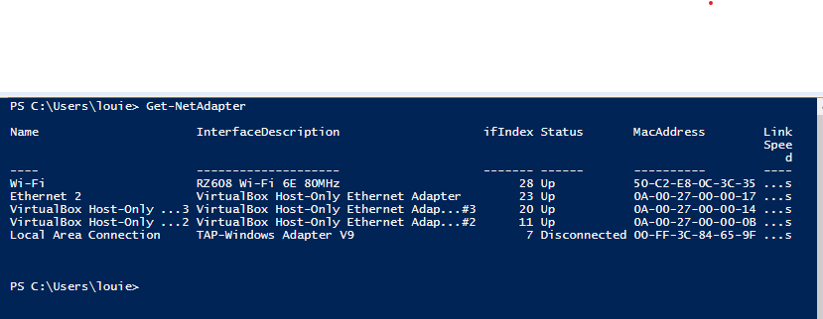

Get-NetIPAddress -InterfaceIndex 28

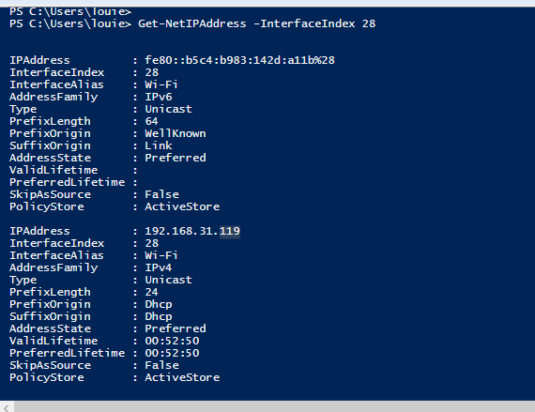

Get-netipconfiguration

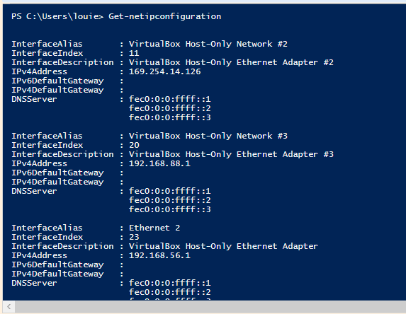

Task 2 - Ping Your Local Router.

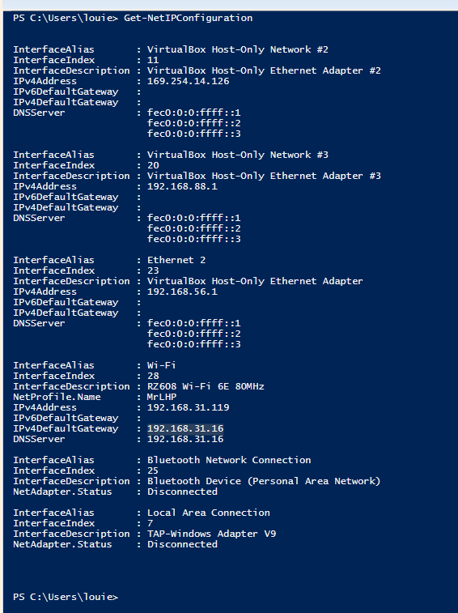

Local router is 192.168.31.16, ping it using Test-NetConnection 192.168.31.16 and Test-Connection command.

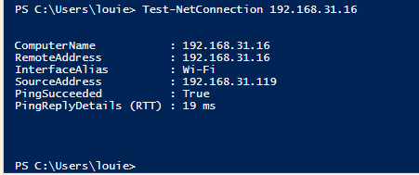

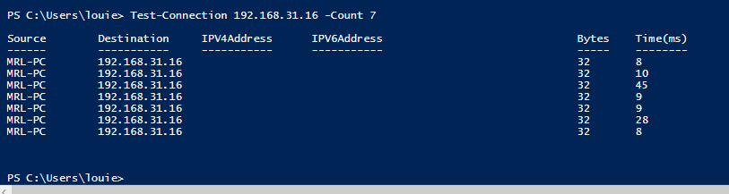

Minimum Ping RTT: **8ms.**

Maximum Ping RTT: **45ms.**

Average Ping RTT around: **19ms.**

Task 3. Ping your OpenWRT Linux Server

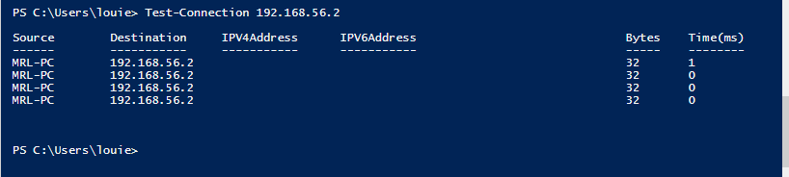

Captured packets on Linux machine save as capfile1.pcap:

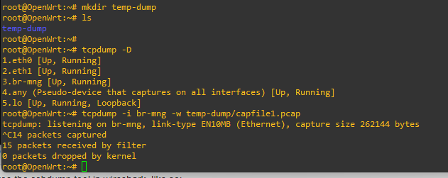

Export to windows machine:

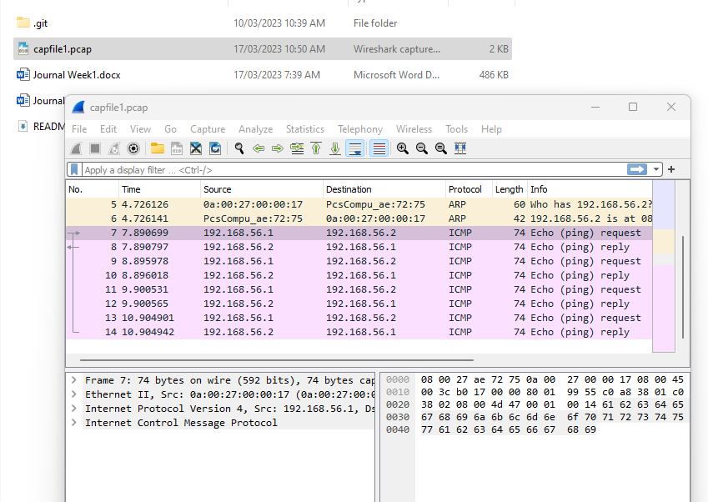

Task 4. Trace Path Through the Internet

Sample within Australia traceroute using Looking Glass ([Traceroute (telstra.net)](https://www.telstra.net/cgi-bin/trace))

* Contains 5 hops from Telstra.net server before reaching my.cqu.edu.au website and the delay is minimal not exceeding 2.3ms.

* Contains 5 hops from Telstra.net server before reaching coles.com.au website and the delay is minimal not exceeding 3.34ms.

Sample international traceroute using Looking Glass ([Traceroute (telstra.net)](https://www.telstra.net/cgi-bin/trace)) to [www.mit.edu](http://www.mit.edu) an international destination.

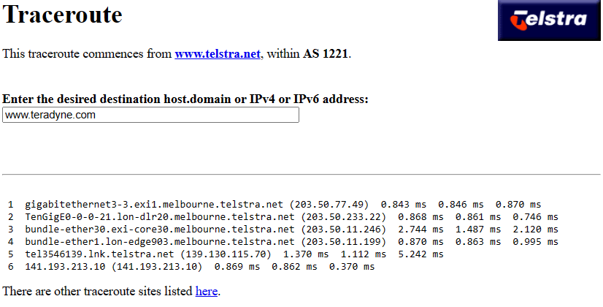

* Contains 6 hops from Telstra.net server going to teradyne.com website, each hops has different delays and the.

*Complementary to the traceroute the ping from the PC going to teradyne.com server reflects a value of 33ms average RTT value.

Task 5. Draw a Network Diagram

Using [Traceroute (telstra.net)](https://www.telstra.net/cgi-bin/trace) as source and teradyne.com as destination.

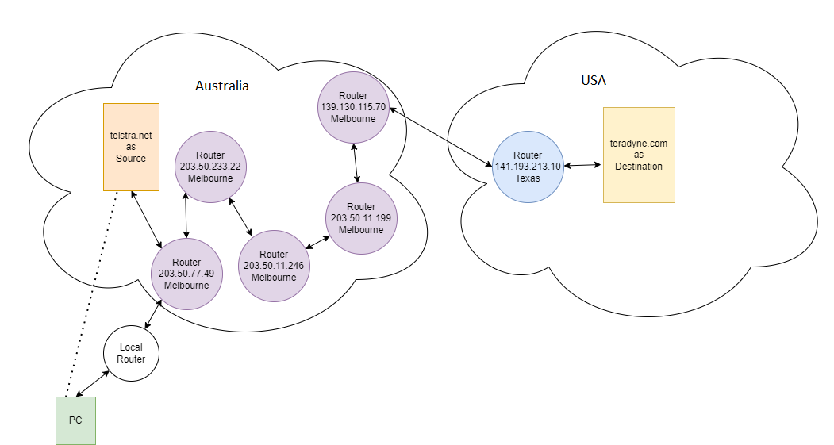

Task 6. Find Addresses of a Website

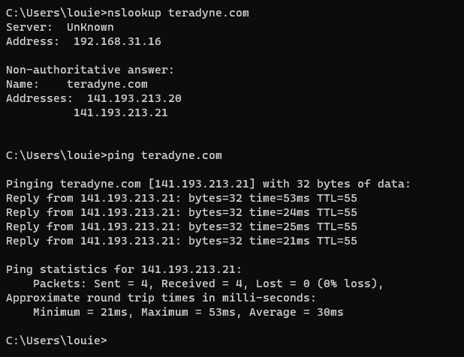

Task 7. Home Internet Connection

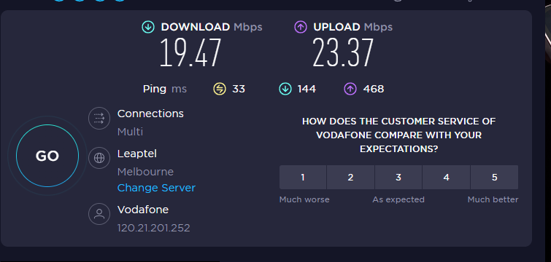

Recorded around 5:00PM.

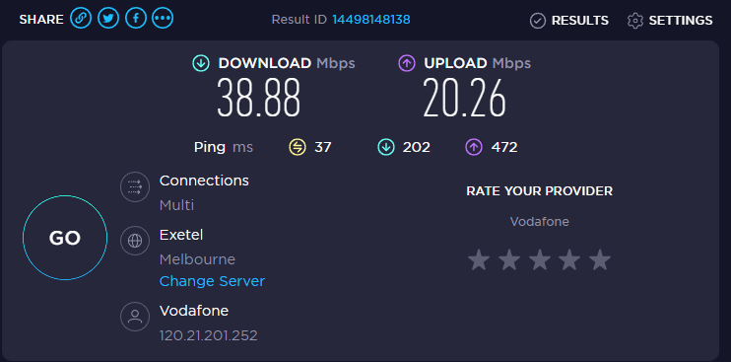

Recorded around 2:40PM.

Type of connection: Mobile data

Internet Service Provider (ISP): Vodafone

Download Speed: ~ 39 Mbps

Upload Speed: ~ 20 Mbps

Public IP: 120.21.253.249

Local IP: 192.168.31.119

Reference:

Traceroute <https://www.varonis.com/blog/what-is-traceroute>

IP lookup: <https://ipinfo.io/>

Diagram: <https://app.diagrams.net/>